

Capstone Project Phase A

Teach-Me: A Web Application For Finding Private Tutors For Students.

Project Number: 23-2-D-21

Supervisor:  
Prof. Zeev Barzilay

[zbarzilay@braude.ac.il](mailto:zbrazily@braude.ac.il)

Ilan Vinerski - 308571785

[ilanv145@gmail.com](mailto:ilanv145@gmail.com)

Orel Damti - 315838375

[oreldamti1996@gmail.com](mailto:oreldamti1996@gmail.com)

Table of contents

1. Introduction 3
   1. The system stakeholders 3
   2. Review of documents 3
2. Background and Related Work 4
   1. related works 4
      1. "Limudnaim" 4
      2. “Gool” 4
      3. "Private Teachers" 4
   2. Agile 4
   3. Client – Server 5
3. Expected achievements 6
   1. Project goals6
   2. Unique Features6
4. Engineering Process \ Research7
   1. Process7
   2. Product8
      1. Use Case Diagram8
      2. Class Diagram9
      3. Activity Diagram 10
         1. Process of Adding Course of Teacher 10
      4. Software Architecture Diagram11
      5. User Interface12
         1. Login Page12
         2. Registration Page 13
         3. Student Registration Page 14
         4. Teacher Registration Page 15
         5. Select course to learn or study 16
         6. Select Teacher Page 17
         7. Select Date 18
5. Evaluation/Verification Plan 19
   1. Unit Testing 19
   2. Functionality Testing 20
6. References 21

Abstract

*Today, many students are helped by private tutors during their studies. One of the problems is that the private tutors charge very high prices, and the students during the degree do not have the money to finance it. So we thought of an idea where students would be helped by students from higher years who have already passed these courses with a high grade and charge a fair price for a private lesson. In this way, students will be able to earn money and earn a living during their degree, and on the other hand, students who need help with their studies will have the opportunity to receive this help at a price they can afford and improve their academic achievements.*

1. Introduction  
   *The "Teach-Me system" is a system that connects students who are looking for a   
   private tutor for a certain course and a student who has already passed this course with a high score and wants to work as a private tutor and earn money during his studies. is a web application*

*Designed to solve the problem of allowing students to teach other students for a fair amount of money.*

*This system is the ultimate tool for the stunts to teach the material they are good at. They will be able to choose which courses they want to teach, they will be able to add more courses later, delete courses they no longer want to teach. Furthermore, the students who will work as private tutors can receive opinions from students they teach.*

*In addition, this solution makes it easier for students to find a suitable private tutor for them by the system showing them all the possible private tutors for a particular course and the ability to contact them directly, thus saving a lot of time.*  
  
1.1 The system stakeholders  
*The potential stakeholders of our system are:  
• Registered users - those who want to schedule a private lesson with a student.  
• Students - those who provide services as a private teacher.  
• Guest users - those who surf the Internet but do not order.*1.2 Review of documents *At the beginning of the book we present the background for choosing the project problem. After that, the main solutions were already developed in the personal training field. Then we will present the principles of the system and how we will implement them. The main chapter of the book details the engineering process we had, the challenges we faced, and the solutions available for the development process. Later, we will represent System structure, logic and interfaces using diagrams. Finally, we will detail the system requirements, and present a detailed test plan.*

2. Background and Related Work:

2.1. related works

*The internet contains several platforms that offer tutorials.*

*each site focused on a different approach to connecting Private tutors for student.*

2.1.1. "Limudnaim"

*"Limudnaim" is a website that offers private lessons on a variety of subjects. Unfortunately, in most cases the teachers on the site do not have the required knowledge that the student needs according to the material studied at the college.*

2.1.2. "Gool" *is a site that offers complete courses for independent learning online. But in many cases the material delivered on the website does not coincide with the material taught at the college and this creates a serious problem for the student who paid for the content on the website but they are not useful to him.*

2.1.3. "Private Teachers" *Private tutors in the free market. There are many good private tutors, but in most cases these tutors demand large sums of money, which the students cannot afford to use for an extended period of time.*

2.2 Agile

*For the development phase we must choose the most appropriate software. We Researched and analyzed our project development methodology several project development methodologies such as Agile and Waterfall. Our conclusion is that Agile is the most appropriate development method for our project. Agile methodology is an iterative approach to project management and breaking down projects into small pieces of software development. Parts of this project are done in work sessions, often called sprints. Sprints usually last from a few days to a few weeks. These meetings range from the initial design phase to testing and quality assurance (QA). The main advantage of the agile development methodology is its flexibility: a product development approach that the development teams react to, will be able to identify changes, even at the last moment, and adapt to them without too many distractions. Therefore, using agile methods will allow us to release the first version system version.*

2.3. Client – Server

*A client-server represents a relationship between cooperating programs An application consisting of clients and servers that initiate service requests Provide the function or service. A client, also known as a service requester, is computer hardware or*

*Server software that requests resources and services provided by a server. A server is a device or computer program that provides functionality to others device or program. Any computer process that can be used or run The clients that share resources and distribute work are servers.*  
  
Client – Server Model?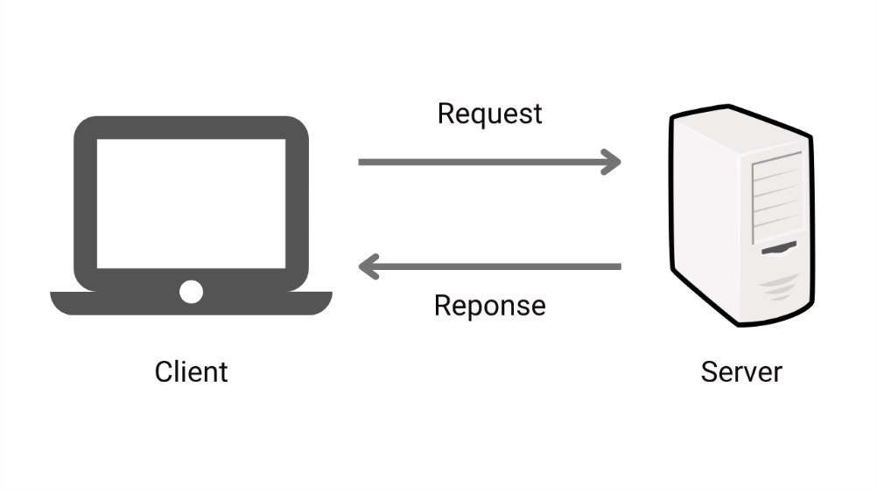

*Client-server architecture is a model for designing and implementing distributed computing systems, where software applications are divided into two main components: the client and the server. The client represents the user interface or the front end, while the server handles the data processing and storage or the back end.*

*Below is a breakdown of the server-client architecture:*

* *Clients: Clients are the end-user devices or applications that interact with users. They can be desktop computers, laptops, smartphones or even web browsers. Clients are responsible for sending requests to the server and receiving responses. They provide the user interface, allowing users to enter data, display results, and interact with the application.*
* *Servers: Servers are powerful computers or systems that receive and process client requests, perform the required calculations and send back responses. Servers handle tasks such as data storage, retrieval, processing and execution of business logic. They are responsible for managing resources, ensuring security and providing services to customers.*

*Servers can be classified into different types:*

* *Web servers: These servers host websites or web applications and respond to HTTP requests. They deliver web pages and other resources to clients using protocols such as HTTP and HTTPS.*

*A client-server architecture offers several advantages, including:*

* *Scalability: Servers can be scaled up to handle increased customer demands by adding additional computing resources.*
* *Centralized management: Data and business logic are stored and managed in a central location, making it easier to maintain and update applications.*
* *Enhanced security: Servers can implement security measures to control access, authenticate users, and protect sensitive data.*
* *Efficient utilization of resources: By offloading processing tasks to the server, customers can focus on providing a smooth user experience without the need for powerful hardware.*
* *Collaboration and Sharing: Clients can access shared resources and collaborate with each other through the server.*

*Overall, client-server architecture provides a flexible and scalable framework for building distributed systems where clients and servers work together to provide efficient and reliable services to end users.*

3. Expected achievements

3.1. Project goals

*- Our main goal is to develop a cross-platform user-friendly application that can run on a wide variety of platforms, including mobile phones, Computers, iPad and other devices.*

*- Mutual support for students.*

*- Students will have the opportunity to expand their knowledge and meet other students.*

*- Teachers will be able to use our site as an effective time management tool for scheduling their private lessons.*

3.2. Unique Features

*1. Our application will have push notifications, which will update about a new teacher who has joined the site.*

*2. Filters and search options are another unique feature of our app. Filters are one of the features that make it easier to use. Finding the right course can be cumbersome. Filters come to the rescue and save time and effort for the users. You can add different filters to different courses to get the Search results as close as possible to what is desired.*

4. Engineering Process \ Research

4.1. Process

*We have created a well-organized work plan covering all processes, Begin the learning process and progress through the development process until we reach a final product that is suitable for system goals. At first, we had to analyze the problem to be solved. our first The task was to precisely define the problem, in other words, what it is A problem that needs to be addressed, who is the product we are  
Developers for, and how important is it to find a solution? To achieve all the above goals, we conducted a survey with Potential stakeholders, who are students who have difficulty with courses and are looking for a private tutor, students who have already been helped by private tutors in the past and present, and also students who want to teach and wish to do so for a fee. Next, we have well defined the system requirements. The next step was to look at potential solutions, we had to research. We examined the various factors regarding each of the potential solutions. The advantages and disadvantages relevant to each solution. After research, we choose the set of tools we will use in development  
project phase, we choose to utilize the MERN stack - On the client side, in addition to HTML, CSS and JavaScript, we decided to use React as a framework. We will implement our server side with  
NodeJS with the ExpressJS library that will allow us to build an API Server. The database we will use is MongoDB. Furthermore, we had to choose the software development methodology for Our project, we realized that Agile is the most appropriate development Methodology for our project.*

4.2 Product

4.2.1. Use Case Diagram

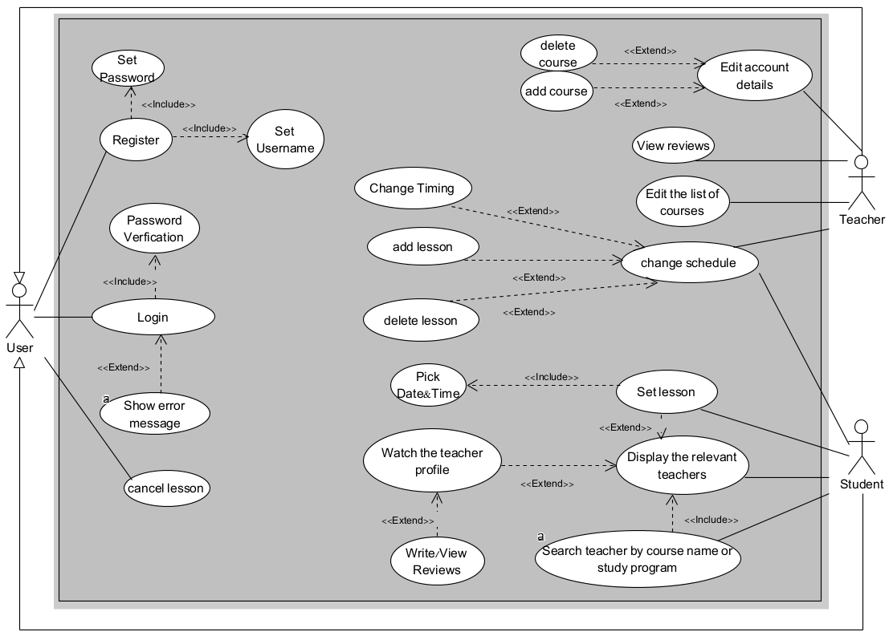

***Fig 1 : Use Case Diagram***

4.2.2. Class Diagram

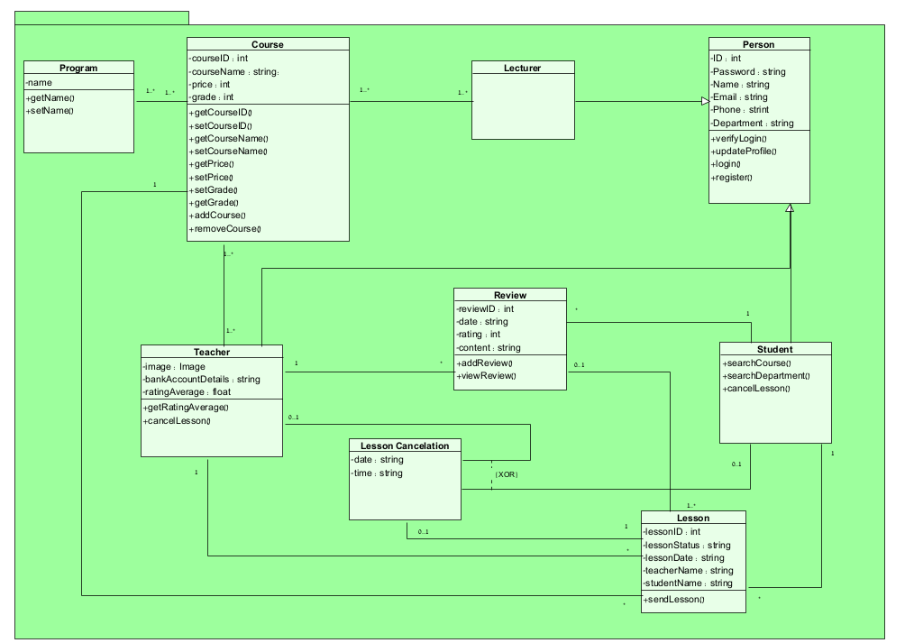

***Fig 2 : Class Diagram***

4.2.3. Activity Diagram

4.2.3.1 Process of Adding Course of Teacher

* + - 1. *The Teacher Login Into the system.*
      2. *The system check if Username AND Password is valid.*
      3. *If System return no go to step 1.*
      4. *The System display list of courses.*
      5. *The teacher select course to teach.*
      6. *The teacher enters the grade in course he wants to teach.*
      7. *The system check if grade above 80.*
      8. *If system return NO the system display message that teacher couldn’t teach this course and go to step 4.*
      9. *The teacher enter price per lesson.*
      10. *The system check if price under 100.*
      11. *If The system returns NO go to step 9.*
      12. *The Teacher chooses available days to teach.*
      13. *The teacher adding course to teacher list.*
      14. *The system asks if you want to add another course.*
      15. *If The Teacher return YES go to step 4.*
      16. *The Teacher returns NO the process, is END.*

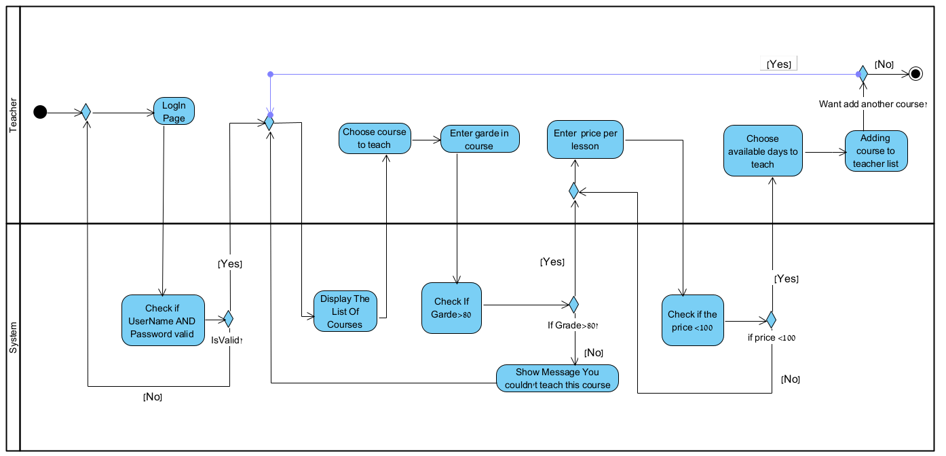

***Fig 3 : Activity Diagram : Adding Course of Teacher***

4.2.4. Software Architecture Diagram

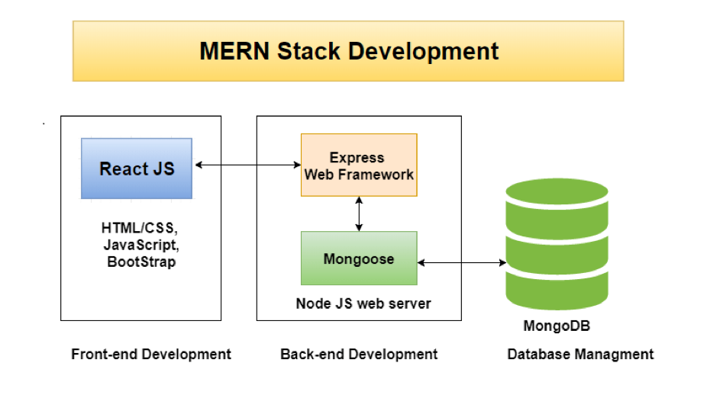

***Fig 4 : Software Architecture Diagram***

4.2.5. User Interface

4.2.5.1. Login Page

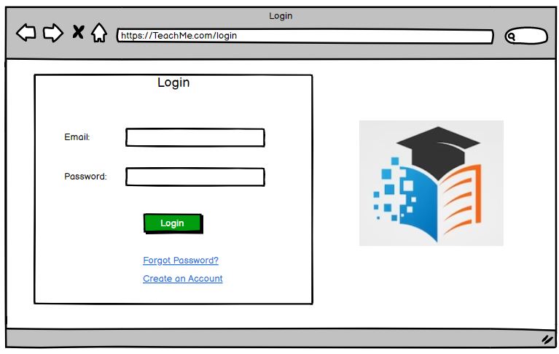

***Fig 5 : Login Page***

4.2.5.2. Registration Page

*After selecting the registration button, the system will ask the user to choose*

*the type of the user, there are two types: Teacher and Student User.*

*After he choose the type, he will move to registration page according to his*

*selection.*

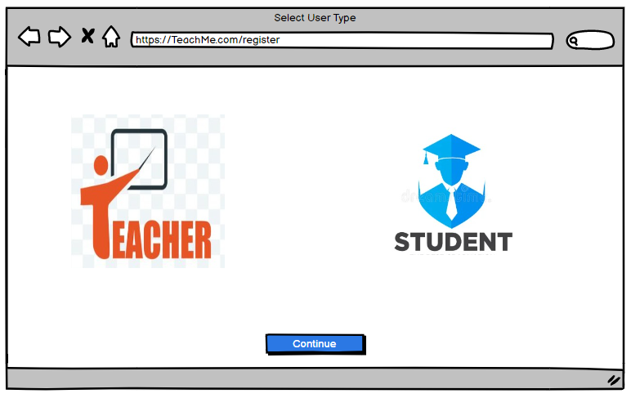 ***Fig 6 : Registration Page – Select User Type***

4.2.5.3. Student Registration Page:

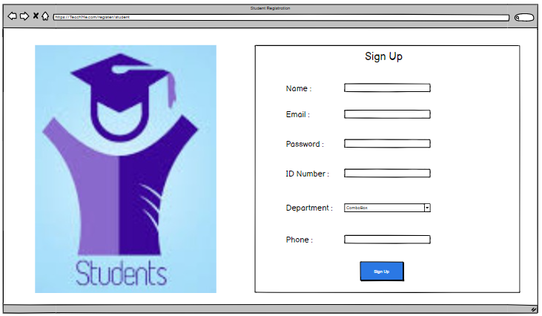

***Fig 7: Student Registration Page***

4.2.5.4. Teacher Registration Page:

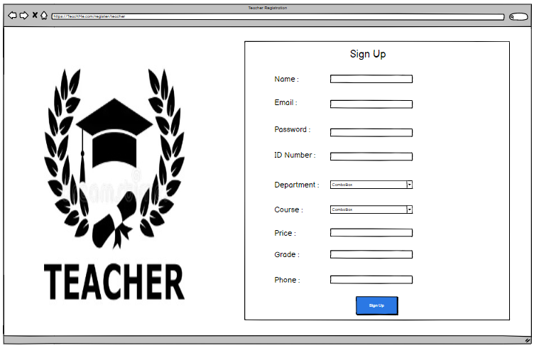

***Fig 8: Teacher Registration Page***

4.2.5.5. Select course to learn or study

*The main dashboard of the system, on this page the student can search*

*the course he wants to study.*

***Fig 9: Choose Course Page***

4.2.5.6. SelectTeacher Page*:*

*After the student has selected the course he wants to learn, the system displays the teachers*

*who teaches this course.*

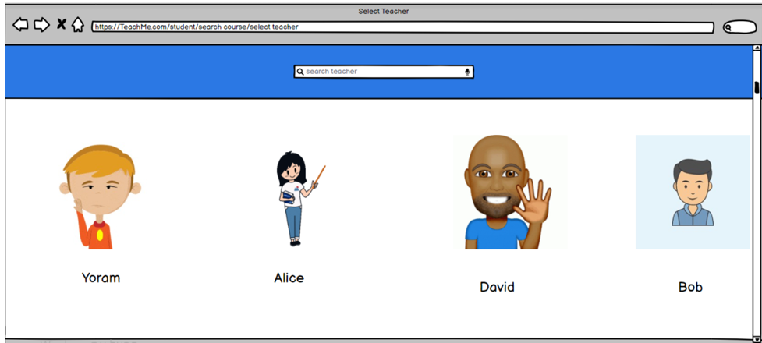

***Fig 10: Select Teacher Page***

4.2.5.7. Select Date*:*

*After the student has selected the course he wants to learn, the system displays the teachers*

*who teaches this course and chooses a date to learn the course what he chosen.*

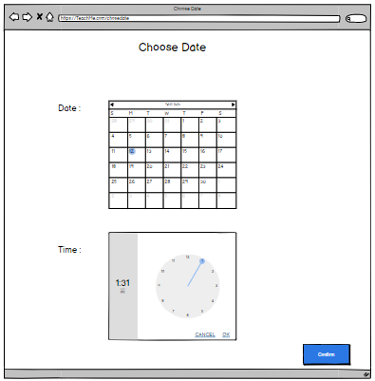

***Fig 11: Choose Date Page***

# Evaluation/Verification Plan

In order to test our system, we will perform two kinds of evaluation tests. The first one is unit testing and the second is functional testing.

# 

| **Registration** | | |
| --- | --- | --- |
| **No.** | **Test Subject** | **Expected result** |
| 1 | Enter an email that already exist in system. | "This email address is already being  used". |
| 2 | Enter invalid Email address | "Invalid email". |
| 3 | Enter an ID number that already exist in system. | "This ID number is already being  used". |
| 4 | Entre wrong phone number | “This phone number is invalid”. |
| 5 | Enter empty one of require fields and click Sign Up | "Please fill all require fields". |
| 6 | Enter course don’t exist | “This course not exist in academic”. |
| 7 | Enter wrong price | “Price cant contain (!@# etc.) or The price is very expensive”. |
| 8 | Enter wrong Grade | “Grade is don’t enough to learn course”. |

# 5.1.Unit Testing

| **Login** | | |
| --- | --- | --- |
| **No.** | **Test Subject** | **Expected result** |
| 9 | Enter empty email or password | "Please fill all fields". |
| 10 | Enter invalid Email address | "Invalid email". |
| 11 | Enter correct email but incorrect password. | "Invalid email or password, try again". |

| **Date** | | |
| --- | --- | --- |
| **No.** | **Test Subject** | **Expected result** |
| 12 | pressed confirm and don’t choose Date or Time | “Invalid Date or Time” |
| 13 | Choose a Date that passed | “Invalid Date” |
| 14 | Choose date equal today and time that passed | “Invalid Time” |

# 5.2. Functionality Testing

| **Login** | | |
| --- | --- | --- |
| **No.** | **Test Subject** | **Expected result** |
| 1 | Enter correct Login details, and press on  Login button. | The screen switches to the home page |

| **Select Course** | | |
| --- | --- | --- |
| **No.** | **Test Subject** | **Expected result** |
| 2 | Enter course name, and press on Search  button. | The screen switches to another page with teacher list. |
| 3 | Select teacher from teacher list | The screen switches to the choose day and hour. |
| 4 | After select day and hour. | The screen switches to Payment |
| 5 | On Payment page enter a card to pay. | The screen present Payment pass successfully. |

1. References

<https://www.methoda.cloud/?section=254>

<https://www.indeed.com/career-advice/career-development/software-development-methodologies>

<https://www.omnisci.com/technical-glossary/client-server>

<https://azure.microsoft.com/en-us/overview/what-is-cloud-> [computing](https://azure.microsoft.com/en-us/overview/what-is-cloud-computing)

<https://www.techtarget.com/searchcio/definition/Agile-> [project-management](https://www.techtarget.com/searchcio/definition/Agile-project-management)